**CURRENCY RECOGNITION**

**A PROJECT REPORT**

###### ***Submitted by***

##### Nakka Rugved (20BAI10078)

**Kanthi Kiran** (20BAI10059)

**Kuruva Manoj** (20BAI10334)

**Pankaja Pandey** (20BAI10007)

*in partial fulfillment for the award of the degree*

*of*

**BACHELOR OF TECHNOLOGY**

*in*

# COMPUTER SCIENCE AND ENGINEERING



**SCHOOL OF COMPUTING SCIENCE AND ENGINEERING**

**VIT BHOPAL UNIVERSITY**

**KOTHRI KALAN5, SEHORE**

**MADHYA PRADESH - 466114**

##### APRIL 2022

**VIT BHOPAL UNIVERSITY, KOTHRI KALAN, SEHORE**

**MADHYA PRADESH – 466114**

**BONAFIDE CERTIFICATE**

Certified that this project report titled **“CURRENCY RECOGNITION”** is the bonafide work of “NAKKA RUGVED(20BAI10078),KANTHI KIRAN(20BAI10059),KURUVAMANOJ(20BAI10334),PANKAJ PANDEY(20BAI10078)**”** who carried out the project work under my supervision. Certified further that to the best of my knowledge the work reported at this time does not form part of any other project/research work based on which a degree or award was conferred on an earlier occasion on this or any other candidate.



**PROGRAM CHAIR PROJECT GUIDE**

Dr.S.Suthir, PC@AIML Dr .Lakshmi D, Project Guide

School of Computer Science and Engineering School of Computer Science and Engineering

VIT BHOPAL UNIVERSITY VIT BHOPAL UNIVERSITY

The Project Exhibition III Examination is held on 29/04/2022

**ACKNOWLEDGEMENT**

First and foremost I would like to thank the Lord Almighty for His presence and immense blessings throughout the project work.

I wish to express my heartfelt gratitude to Dr S Suthir, Programme chair, School of Computer Science and Dean Dr S. Poonkuntran School of Computer Science for much of his valuable support and encouragement in carrying out this work.

I would like to thank my internal guide Dr Lakshmi D, for continually guiding and actively participating in my project, giving valuable suggestions to complete the project work.

I would like to thank all the technical and teaching staff of the School of Computer Science, who extended directly or indirectly all support.

Last, but not least, I am deeply indebted to my parents who have been the greatest support while I worked day and night for the project to make it a success.

**LIST OF FIGURES AND GRAPHS**

|  |  |  |
| --- | --- | --- |
| **FIGURE NO.** | **TITLE** | **PAGE NO.** |
| 2.1 | currency Notes of different Sizes | 14 |
| 2.2 | various Indian Currency notes | 14 |
| 2.3 | The new Rs 2000 and Rs 5000 currency | 15 |
| 2.4 | Indian banknotes for currency identification | 16 |
| 2.5 | 50 rupees denomination recognition | 20 |
| 2.6 | 50 rupees denomination recognition | 20 |
| 4.1 | Brute Force classification | 25 |
| 4.2 | Data flow diagram | 27 |
| 4.3 | ER-Diagram | 28 |

**ABSTRACT**

Indian currency note's higher denominations like 500 and 1000 have different color, identification marks and different sizes for their recognition but still the normal people as well as blind people fail in recognition of authenticity of currency notes. Due to the complications which the blind people as well as normal people are facing related to recognition and authentication, we have developed an android app for recognition and authentication of currency notes, which can be an assistive tool for a blind person and authenticity detector tool for a normal person. This paper focuses on the recognition and authentication of the currency note. The recognition of the note is done by using the preprocessing techniques and the authentication of the note is done by applying OCR techniques and Serial number extraction and comparison of serial number with CSV file and an audio output is generated using TTS Speech Synthesizer.

**Keywords**

Android, Currency recognition, Comma Separated

Value(CSV), Image Preprocessing, Gray Scale, HSV(Hue

Saturation Value), Optical Character Recognition(OCR), Speech

synthesizer, Segmentation, TTS (Text To Speech).

**TABLE OF CONTENTS**

|  |  |  |
| --- | --- | --- |
| **CHAPTER NO.** | **TITLE** | **PAGE NO.** |
|  | List of Figures and Graphs  List of Tables  Abstract | iv  v  vi |
| 1 | **CHAPTER-1:**  **PROJECT DESCRIPTION AND OUTLINE** Introduction 1.2 Motivation for the work  1.3 Problem Statement  1.4 Objective of the work  1.5 Summary | 9  9  10  11  12  . |
| 2 | **CHAPTER-2:**  **RELATED WORK INVESTIGATION**  2.1 Introduction  2.2 Existing Approaches/Methods  2.2.1 Approaches/Methods -1  2.3 Implementation  2.4 Result  2.5 Summary | 13  13-15  16  17  18-19  20 |
| 3 | **CHAPTER-3:**  **REQUIREMENT ARTIFACTS**  3.1 Introduction  3.2 Hardware and Software requirements  3.3 Specific Project requirements  3.3.1 libraries  3.4 Summary | 21  21  21  22  23  24 |
| 4 | **CHAPTER-4:**  **DESIGN METHODOLOGY AND ITS NOVELTY**  4.1 Methodology and goal  4.2 Software Architectural designs  4.2.1 Data flow diagram  4.2.2 ER Diagram  4.2.3 Sequence Diagram  4.3 Test services  4.4 User Interface designs | 25  25-26  27  28  29  30  31 |
| 5 | **CHAPTER-5:**  **TECHNICAL IMPLEMENTATION & ANALYSIS**  5.1Outline  5.2 Technical coding and code solution  5.3 Summary | 32  32  34-37 |
| 6 | **CHAPTER-6:**  **PROJECT OUTCOME AND APPLICABILITY**  6.1Outline  6.2 Significant project outcomes  6.3 Project applicability on Real-world applications | 38  38  38-41  42 |
| 7 | **CHAPTER-7:**  **CONCLUSIONS AND RECOMMENDATION**  7.1Outline  7.2 Limitation/Constraints of the System  7.3 Future Enhancements | 43  43  44 |
|  | References | 45 |

**CHAPTER-1:**

**PROJECT DESCRIPTION AND OUTLINE**

**1.1 Introduction**

Currency paper note is still a most commonly used mode of monetary transaction besides so many other ways of transaction. The appealing features of the paper currency include durability, privacy, simplicity and complete control. But it fails in case of value transaction because it lacks intrinsic value and in case of repudiation, it fails in mechanism of reversal, except the credential support by the state. Image Processing is widely used in the field of currency recognition. Automatic systems for currency note recognition holds importance in many applications such as automated teller machines and automated goods seller machines which are very costly. Our system is designed to recognize and verify the Indian paper currency. Our approach includes a number of steps including image cropping, gray scale conversion, RGB, HSV, thresholding, Segmentation, Boundary detection, OCR of images.

Firstly, a large number of training samples are created which are used to avoid overfitting and poor generalization. Secondly, if the distribution of the training sample is non-uniform, the result will probably converge to a local optimal or will even diverge unreasonably. Therefore, the selection of the training set is a crucial issue for the Image processing. In currency circulation, the original information on paper currency may incur loss because paper currency may be worn, blurry, or even damaged. Furthermore, the complicated designs of different forms of paper currencies make automatic currency recognition difficult to work well.

So therefore, it is difficult to extract the characteristic information from currency images and select proper pattern recognition algorithms to improve the accuracy of currency recognition. The method we present here has an excellent performance. In this paper, we have designed a first android app on currency which can recognize as well as authenticate the currency note. Preprocessing techniques are applied for recognition and OCR techniques are applied for Serial number extraction. Later, the extracted Serial number template is matched with fake serial number series templates in a CSV file stored in Database. If matched, then fake note else original note.

**1.2 Motivation for the work**

The seeds for this work were sowed in late 2006, when one of us, was cheated by receiving a counterfeit currency of ₹500 and had to resolve that issue by destroying that currency. This made a loss of ₹500 but sparked a thought, that having been given two eyes, if a person could be cheated then any kind of financial cheating could happen to the blind people! From our own experiences, we learned that the currency, be it a coin or note, identification, is really a herculean task for the blind people. This laid down the foundation for our work.

In addition to this, in earlier days, as the previous section discusses, the coins were of different sizes and shapes and hence the identification was quite easy. Since 2011, as discussed in the previous section, RBI put an end to manufacturing the coins of different sizes and introduced coins of almost the same size and weight. This made the identification of coins more difficult for the blind people. The mixture of old and new coins makes the task tougher.

The paper based currencies have also been changed in their size along with other features, especially after demonetization which made the life of blind people worse. Like ₹500 and ₹2000 notes are smaller in size than current ₹100 and ₹50 notes. Due to such minor variations in the size of the paper based currency and frequent addition of new features to enhance the security, the identification for the same becomes more difficult than the coins. And when the currency is counterfeit or torn out, the identification becomes, even more, difficult, for the blinds. Money is something for which people are, usually, being cheated. Especially, if the person is blind, there are more chances of him/her being cheated. India, according to WHO reports (March, 2017), has 12 million blind people which is 1/3rd of total of 39 million people all over the world. Also, in India, the currency recognition tools are available to the Banks only which are neither affordable nor handy to a common man! In order to prevent the cheating and to serve the unprivileged people of the society, visually impaired people, we thought to do this work. The next section discusses the problem definition, objectives of this work, our research contributions and possible applications of our work.

**1.3 Problem State**

Post demonetization, the sizes of the Indian currency notes have drastically changed. For example, the new Rs.100 and Rs.200 notes have similar physical dimensions. Though the color of such notes is very contrasting, this difference is beneficial only to those blessed with eyesight. The population of the visually challenged in India is a staggering 36 million. These people have a hard time identifying these new notes (even the Braille and small dots and holes on these notes seem to fade away with prolonged usage). This project aims to relieve some of their problems using assistive technology.

Unsighted people face the problem of not being able to recognize the paper currency due to the similarity of paper texture between the different categories. These people face a lot of difficulty in their money transactions. In order to find a solution to this problem, we need to develop a technical solution which is cost effective and efficient to use for people.

To design and develop a computer vision algorithm(s) that can recognize Indian currency denominations and translate it into Indian vernacular language.

**1.4 Objective of the work**

**AIM OF THE PROJECT :**

To develop a GUI Application to detect currency notes to a blind people.

A GUI App is made for the user's interference and to detect and predict the currency notes and voice output for the number of currency notes values are provided as voice output.

**SCOPE OF THE PROJECT :**

The scope of this project is to do currency detection of Indian rupees notes and by it the blind people can easily count the value of the currency notes which are shown in front of the camera in the input image.

In order to achieve our noble goal, we planned:

1. To design and develop an algorithm(s) that can recognize the denomination of the Indian currencies.

2. To ensure that, along with denomination identification, it also checks if the currency is counterfeit or not.

3. To make the algorithm(s) lighter in terms of memory and time both so as to be usable for handheld devices.

4. To develop the algorithm(s) in such a way so that it/they can survive the events like demonetization and can adapt the new currencies.

5. To develop a test tool for the proposed algorithm(s) so ensure that the objectives are met.

The main objective of this project is to recognize the currency using image processing.The Indian currency system includes banknotes and coins, among which banknotes are the primary form of currency used in abundance. Senior citizens experience presbyopia, a natural loss of the ability to focus, which causes difficulty identifying the denomination of banknotes. With the introduction of additional currency notes post demonetization in India, blind people have not been accustomed to the fresh notes, and identification of notes is a hassle. Scammers use this to their advantage to dupe the blind and elderly and give them the wrong denominations. With the demonetization of old ₹500 and ₹1000 notes, new ₹500 and ₹2000 currency notes were introduced, which brought lots of hardships to the visually impaired. It was difficult for them to recognize the new notes.

A system to recognize the correct denominations of the currency notes is much needed, and this study proposes to do just that by using deep learning. Most of the currently existing methods for verifying the validity of a banknote rely on hardware systems with Ultraviolet light. These hardware systems are only available in banks and not accessible to vendors or the general public. We propose a system to identify counterfeited notes through scanned images by applying multiscale template matching implemented using OpenCV in Python. Currency counterfeit detection is an essential task as the security features present in a currency note that help identify its genuineness have changed with the introduction of new currency notes

**1.5 Summary**

This project presents progressive efforts for developing an assistive technology for visually impaired so that they can lead their life independently both socially and financially.

The Currency Detection is used to count the rupees value of the note which is an image is given as input to a model.By using opencv an image processing can be made with the python programming from that technique the images can be classified and they are detected. From this the blind people will be able to count the values of that currency notes which they gave as input images in our model.

**CHAPTER-2:**

**RELATED WORK INVESTIGATION**

**2.1 Introduction**

The Reserve Bank of India, formally started in 1935, is the chief controlling authority for the issuance of the currency. In earlier days, India currency was from 1 Aana to 100 Rupees. The currency had denominations like 1, 5, 10, 20, 25 and 50 in terms of paisa. However, except ₹1 and ₹2 coins, the other coins have been discontinued and new coins of ₹5, ₹10, ₹20, ₹50, ₹100 and ₹500 have been introduced. The currency is available in a denomination value of ₹1, ₹2, ₹5, ₹10, ₹20, ₹50, ₹100, ₹500 and ₹2,000. The symbol for Indian rupee is, ₹, designed by D. Udaya Kumar. On 15 July 2010, Government of India declared it the official sign for Indian Rupee. The currently running series was introduced in 1996 and is called the Mahatma Gandhi series. Since then every Indian currency note has a Mahatma Gandhi photo on it. These currency notes are printed at the Government of India’s Currency Note Press located at Nashik, Dewas, Salboni, Mysore and Hoshangabad. Each banknote has its denomination written in 18 Indian languages of which English, Hindi and Devanagari languages are used on front and back side and other 15 regional languages of India on the back side. New notes of ₹2,000 and ₹500 have different size and security features. Now, in India, the ATMs usually dispense ₹100, ₹500, and ₹2000 currency notes. Following images show sizes of various Indian currencies.

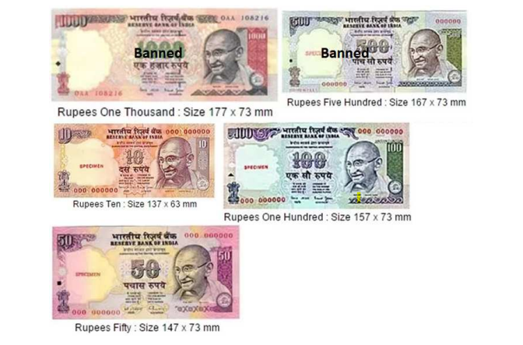

fig 2.1 Currency Notes of different Sizes

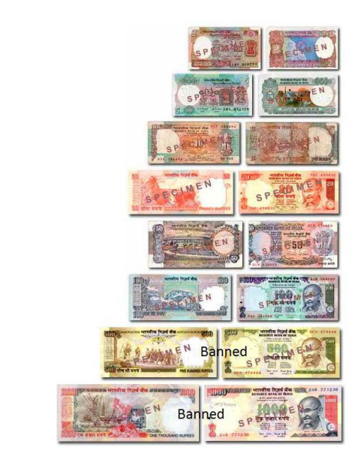

fig 2.2 Various indian currency notes

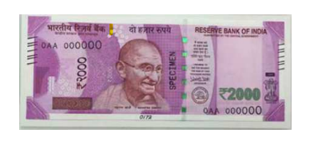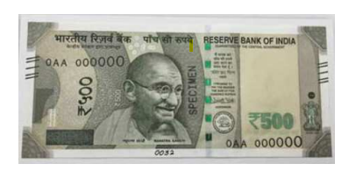

fig 2.3 The new Rs 2000 and Rs 500 Currency 1028*1028 pixels

**2.3 Existing Approaches /Methods**

INDIAN CURRENCY FEATURES

This section gives a brief description of the Indian currency features that have been used for banknote recognition in the proposed method. These features, as shown in Fig. 2, are: The Central Numeral (A), Ashoka Pillar Emblem (B), Identification mark (C) and the Colour Band (D). The monetary value of the Indian currency is printed in both figures and words. The central numeral depicts the monetary value of the currency note most prominently. This feature is unique for each currency denomination. The Ashoka Pillar Emblem, present on the lower left hand side of the note in all Indian currency denominations, has been used to distinguish the rupee from other currencies. The Identification Mark is a special feature in intaglio printing located on the left-hand side middle portion of the banknote. The shapes are different for each denomination of Indian currency and aid the visually impaired in identifying the currency value. The color band runs along the right border of the note and is different for different currency values. It can thus be used to distinguish between currency denominations.

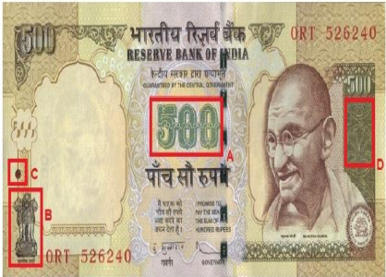

fig 2.4 Indian banknote for currency identification

A. Central Numeral The Central Numeral is the most distinguishing feature in every denomination of the Indian currency. A bag of features

B. Ashoka Pillar Emblem Recognition The emblem is a distinctive feature of the Indian currency with a nearly constant aspect ratio.

C. Identification Mark The identification mark is recognized using normalized correlation technique through template matching.

D. Colour Recognition The CIE LAB Color Space model has been employed for color analysis of the banknotes. This color space model defined by CIE has two color channels (a and b) and a single channel for luminance (lightness), making it an opponent color based system

**2.2.1 Approaches/Methods -1**

The system proposed here works here on the image of currency note under ultraviolet light acquired by a digital camera. The algorithm which is applied here is as follows

1. Acquisition of images of currency notes under ultraviolet light by simple digital camera or scanner.

2. Image acquired is RGB image and now is converted to grayscale image.

3. Edge detection of the whole gray scale image.

4. Now characteristics features of the paper currency will be cropped and segmented.

5. After segmentation, characteristics of currency notes are extracted.

6. Intensity of each feature is calculated.

7. If the condition is satisfied, then the currency note is said as original otherwise fake. In this method, characteristics of currencies are employed which are used by common people for differentiating for different banknote denominations. The characteristics that can be used to check the authentication of currency note are

A. Security Thread

It is a 3mm windowed security thread with inscriptions of India in Hindi, RBI and 2000/500 on banknotes with color shift. Color of the thread changes from green to blue when the note is tilted.

B. Serial Number

Serial number panel with banknote number growing from small to big on the top left side and bottom right side.

C. Latent image

A vertical band on the front side of the denomination at right hand size. It contains a latent image showing the denomination when the banknote is held horizontally at eye level.

D. Watermark

The portrait of Mahatma Gandhi, and multidirectional lines and a mark showing the denominational numeral appear which can be viewed when held against light.

E. Identification Mark

A mark with intaglio print which can be felt by touch, helps blind people to identify the denomination. In 500 denomination the mark is of five lines while in 2000 line the mark is of seven line

**2.3 Implementation**

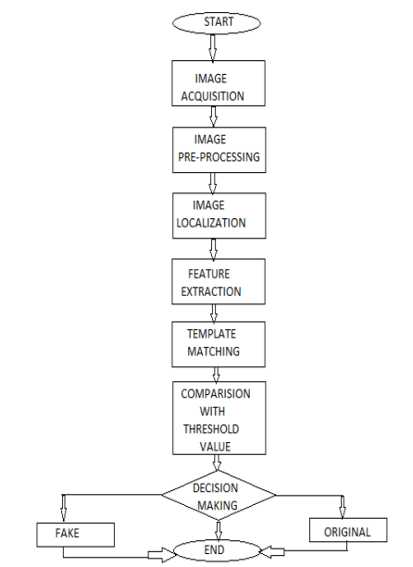

A. Image acquisition: Image acquisition is a process of acquiring an image with the help of a device, the acquired image is stored for further processing.

B. Image pre-processing: Image pre-processing is done to enhance some image features important for further processing and analysis. Resizing: The size of the image is reduced by using MATLAB function ‘imresize’. Removing noise: When image is captured there are chances that image gets blurred and noise may be added to the image and it’s necessary that this should be removed and image should be smoothened.

C. Image localization: When a web camera captures the image of currency then the image contains background maintained below currency, for processing of an image and to get correct results it is necessary to remove the background and keep the image of currency as it is.

D. Feature extraction: Using feature extraction technique it is possible to extract the feature of available image and these extracted features are compared with known features to detect counterfeit and denomination of currency

E. Template matching: Template matching technique is used to identify denomination of currency .

F. Comparison with threshold values: Once all the results obtained from above mentioned algorithms now these obtained results will be compared with threshold values.

**2.4 Result**

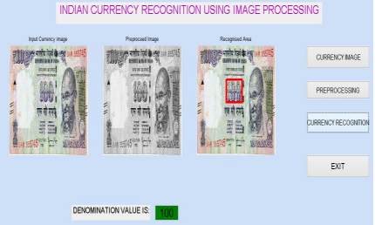

fig 2.5 100 rupees denomination recognition

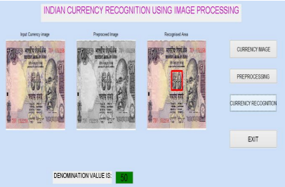

fig 2.6 50 rupees denomination recognition

**2.5 Summary**

The fake currency detection using image processing was implemented on MATLAB. Features of currency notes like serial number, security thread, Identification mark, Mahatma Gandhi portrait were extracted. The process starts from image acquisition to calculation of intensity of each extracted feature. With the help of the above proposed method, it is possible to develop a system which will easily detect the denomination of Indian currency and also it checks the originality of Indian currency with the help of basic image processing algorithm. The system is capable of extracting features even if the note has scribbles on it.

**CHAPTER-3:**

**REQUIREMENT ARTIFACTS**

**3.1 Introduction**

In this chapter we gone through the hardware and software requirements for the functioning of the project and the libraries used in the code ,data sets used for the training the model and test data set for predicting the results

**3.2 Hardware and Software requirements**

**Hardware requirements: ​**

* Processor – Intel Core 3 OR MORE​
* Memory – 1GB Ram & more memory improves performance.​
* Mobile with Camera
* USB cable connector

**Software requirements:​**

* Windows 7 or Higher​​
* VS code
* Python​
* Android studio app development
* preimage data set of currency

**3.3 Specific Project requirements**

**3.3.1 libraries**

**1.Matplotlib**

[**matplotlib.pyplot**](https://matplotlib.org/stable/api/_as_gen/matplotlib.pyplot.html#module-matplotlib.pyplot) is a collection of functions that make matplotlib work like MATLAB. Each pyplot function makes some change to a figure: e.g., creates a figure, creates a plotting area in a figure, plots some lines in a plotting area, decorates the plot with labels, etc.

In [**matplotlib.pyplot**](https://matplotlib.org/stable/api/_as_gen/matplotlib.pyplot.html#module-matplotlib.pyplot) various states are preserved across function calls, so that it keeps track of things like the current figure and plotting area, and the plotting functions are directed to the current axes (please note that "axes" here and in most places in the documentation refers to the *axes* [part of a figure](https://matplotlib.org/stable/tutorials/introductory/usage.html#figure-parts) and not the strict mathematical term for more than one axis).

**2.OS**

It is possible to automatically perform many operating system tasks. The OS module in Python provides functions for creating and removing a directory (folder), fetching its contents, changing and identifying the current directory, etc.

You first need to import the OS module to interact with the underlying operating system. So, import it using the import os statement before using its functions.

**3.playsound**

The playsound module contains only one thing - the function (also named) playsound.It requires one argument - the path to the file with the sound you’d like to play. This may be a local file, or a URL. There’s an optional second argument, block, which is set to True by default. Setting it to False makes the function run asynchronously.

On Windows, uses windll.winmm. WAVE and MP3 have been tested and are known to work. Other file formats may work as well.

On OS X, uses AppKit.NSSound. WAVE and MP3 have been tested and are known to work. In general, anything QuickTime can play, playsound should be able to play, for OS X.

On Linux, uses GStreamer. Known to work on Ubuntu 14.04 and ElementaryOS Loki. I expect any Linux distro with a standard gnome desktop experience should work.

**4.time**

The Python time module provides many ways of representing time in code, such as objects, [numbers](https://realpython.com/python-numbers/), and strings. It also provides functionality other than representing time, like waiting during code execution and measuring the efficiency of your code.

**5.gtts**

gTTS (*Google Text-to-Speech*), a Python library and CLI tool to interface with Google Translate's text-to-speech API. Write spoken mp3 data to a file, a file-like object (bytestring) for further audio manipulation, or stdout.

## Features

* Customizable speech-specific sentence tokenizer that allows for unlimited lengths of text to be read, all while keeping proper intonation, abbreviations, decimals and more;
* Customizable text pre-processors which can, for example, provide pronunciation corrections;

**3.4 Summary**

In this chapter we saw the software and hardware requirements of this project required and the modulus and libraries used in the source code of the project.libraries used in this project are open cv, Matplotlib,os,playsound,time,gtts.

**CHAPTER - 4**

**DESIGN METHODOLOGY AND ITS NOVELTY**

**4.1 Methodology and goal**

**DESIGN AND METHODOLOGIES**

**MODULE 1:**

Data Collection and training using image processing

**MODULE 2:**

Real Time data gathering and prognostics GUI design

**IMAGE CLASSIFICATION ALGORITHMS**

**Brute Force Classification**

The descriptor of one feature in the first set is matched with all other features in the second set using a distance calculation and the closest one is returned as the most matched one. For any two images it calculates the hamming distance using the descriptors and returns the point with minimum hamming distance. The following key point/descriptor mapping was obtained.

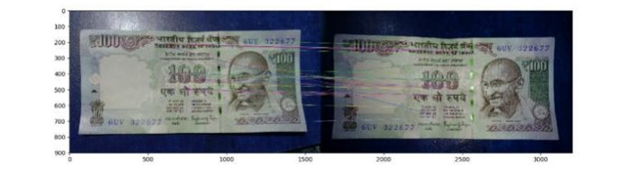 fig 4.1

**Resize Image :**

while pictures are not sufficient for training the data. So By using image data generator, resize image algorithm to convert the pixel value 1028*1028 constant for every image, By using OpenCV library.

The computer vision library is used for image processing.

Then we preferred a training data set .By using the process called data argumentation, there is a generator which generates the 50 images into 1000 of images. So it Converts 50 images into 1000 images using a data argumentation process.

**Image data generator**

By using Image Data generator we generates maximum number of images,

Also by using keras image data generator augment the images in real-time while the model is still training! The random transformations on each training image as it is passed to the model. This will not only make the model robust but will also save up on the overhead memory!

So it is used to expand the training dataset in order to improve the performance and ability of the model to generalize.

**4.2 Software Architectural Designs**

**4.2.1 Data Flow Diagram:**

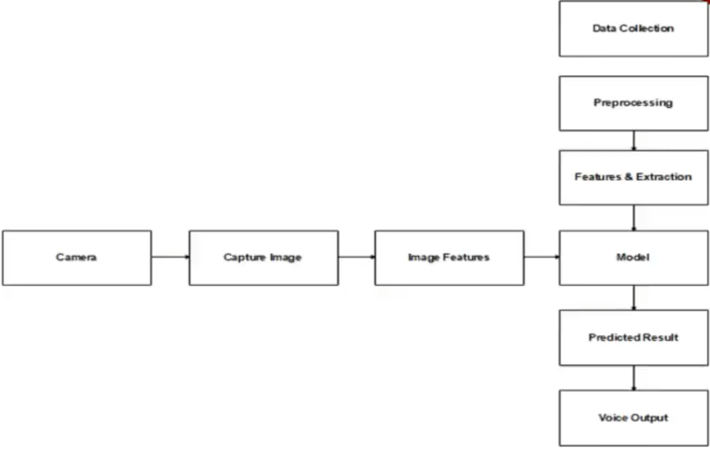

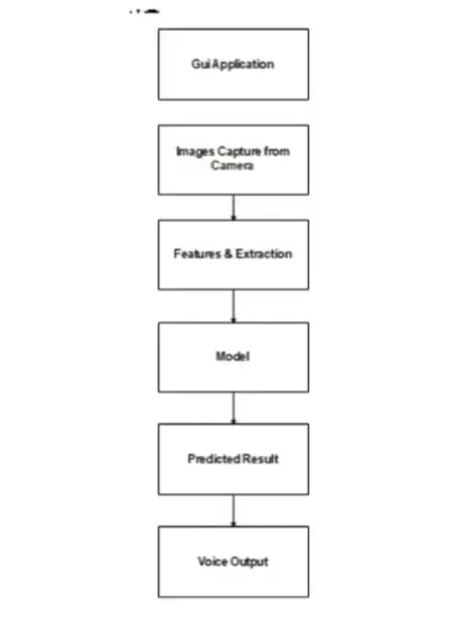

fig 4.2

**4.2.2 ER- Diagram:**

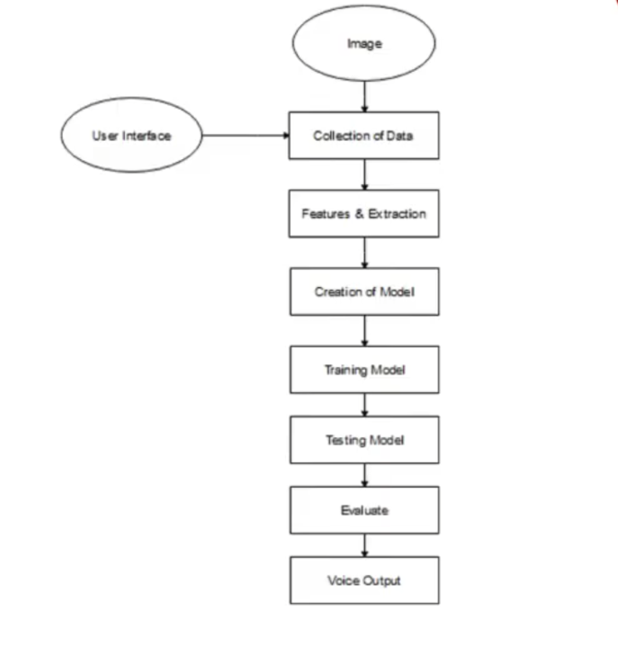

fig 4.3

**4.2.3 Sequence Diagram :**

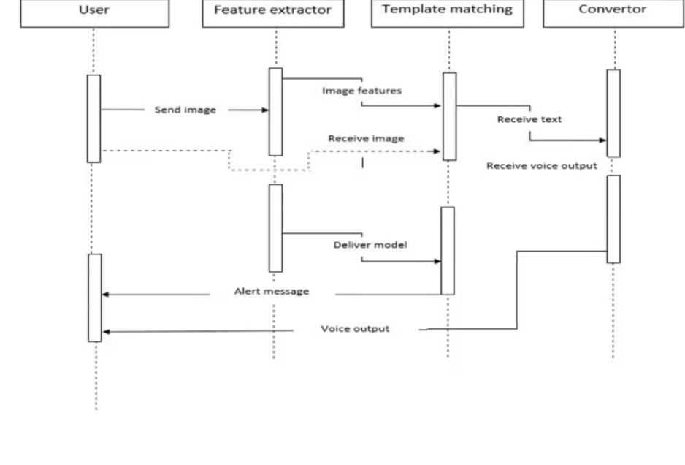

fig 4.4

**4.3 Test services**

UNIT TESTING

INTEGRATION TESTING

FUNCTIONAL TESTING

WHITE BOX TESTING

BLACK BOX TESTING

**1.Unit Testing**

Primary goal of unit testing is to find the smallest piece of testable software in the application, isolate it from the remainder of the code, and determine whether it behaves exactly as you expect. Each unit is tested separately before integrating them into modules to test the interfaces between modules. Unit testing has proven its value in that a large percentage of defects are identified during its use.

**2.Integration Testing**

Testing is done for each module, After testing all the modules, the modules are integrated and testing of the final system is done with the test data, specially designed to show that the system will operate successfully in all its aspects conditions.

**3.Functional Testing**

Functional testing is a type of software testing that validates the software system against the functional requirements/specifications. The purpose of Functional test is to test each function of the software application, by providing appropriate input, verifying the output against the functional requirements.

**4.White Box Testing**

This is a testing technique used in unit testing. White Box Testing is just the vice versa of the Black Box Testing. They do not watch the internal variables during testing. This gives a clear idea about what is going on during execution of the system. The point at which the bug occurs were all clear and were removed

**5**.**Black Box Testing :**

Black Box testing is a software testing method in which the functionalities of software applications are tested without having knowledge of internal code structure, implementation details and internal paths. Black Box Testing mainly focused on input and output.

**4.4 User Interface Design**

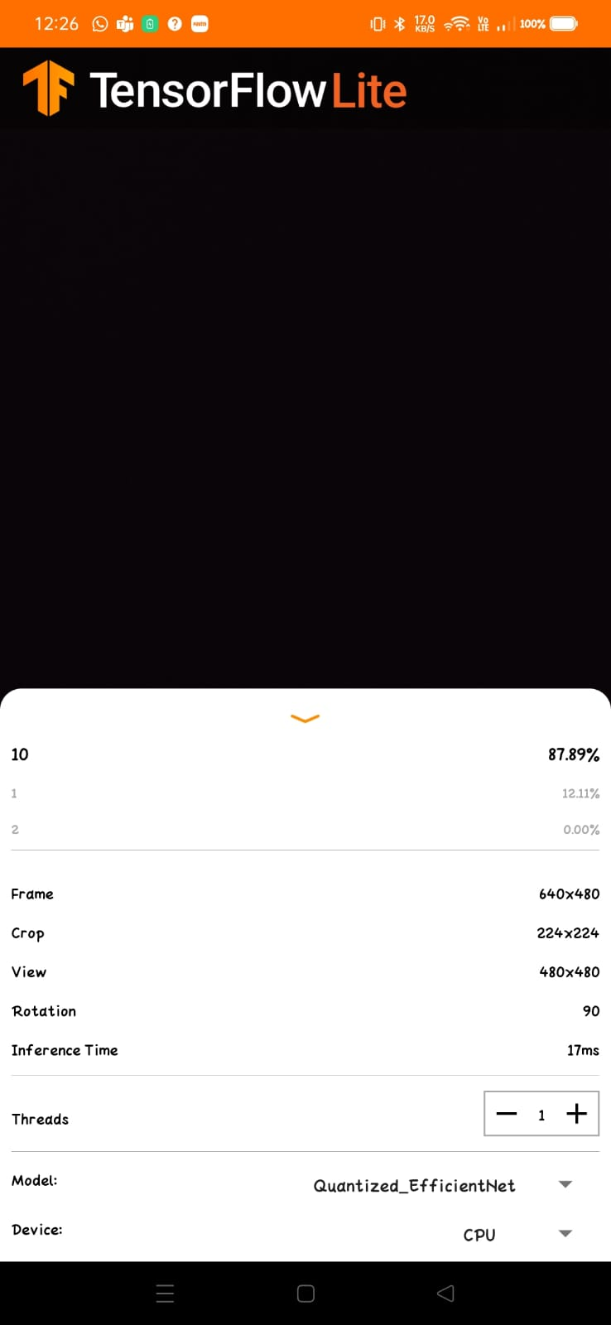

fig 4.5 user interface design

**CHAPTER-5**

**TECHNICAL IMPLEMENTATION & ANALYSIS**

**5.1 Outline**

In this chapter we discuss the code and its working,first we implemented the code in vscode using modules and libraries of python. and then imported the data to android studio and built a small gui to recognise the currency

**5.2 Technical coding and code solution**

**detect.py for currency recognition**

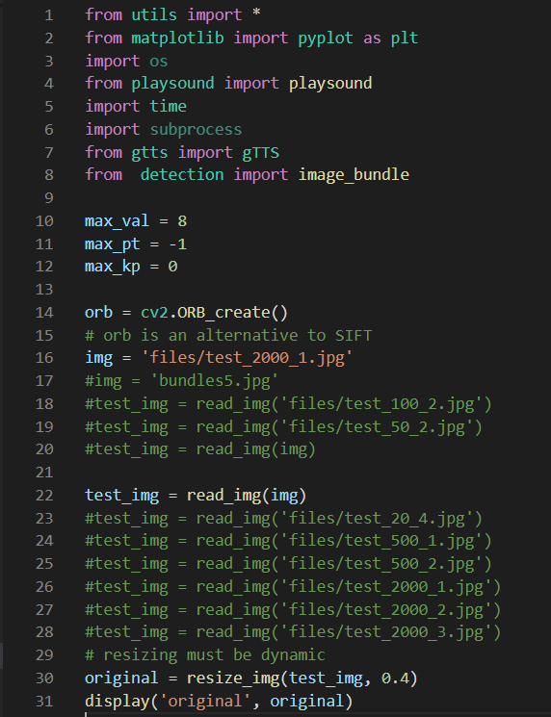

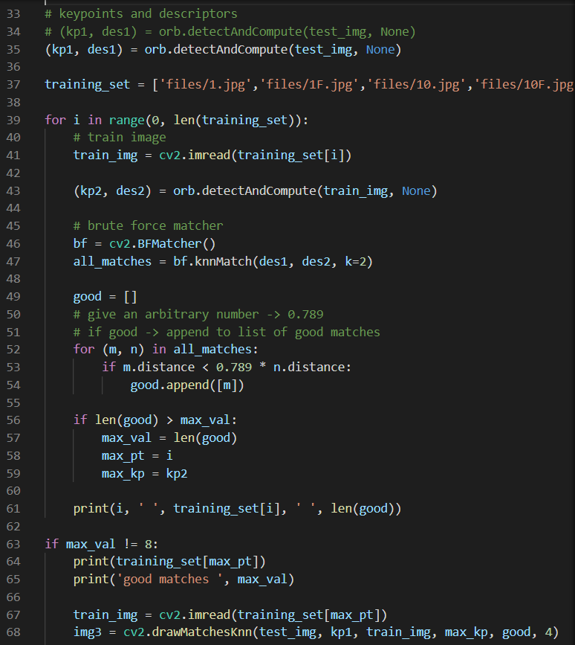

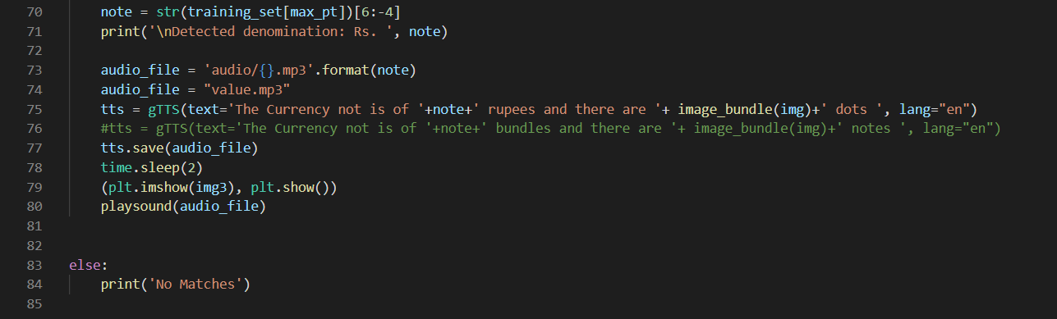

**Detection Code**

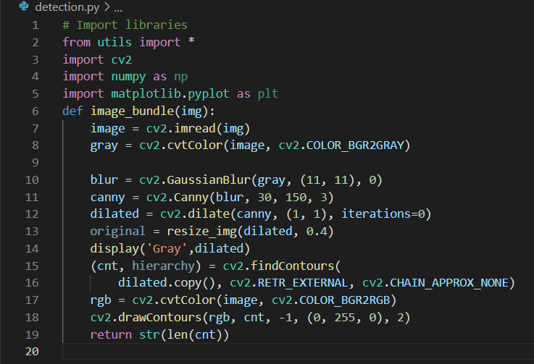

**Android studio code:**

**Camera Activity**

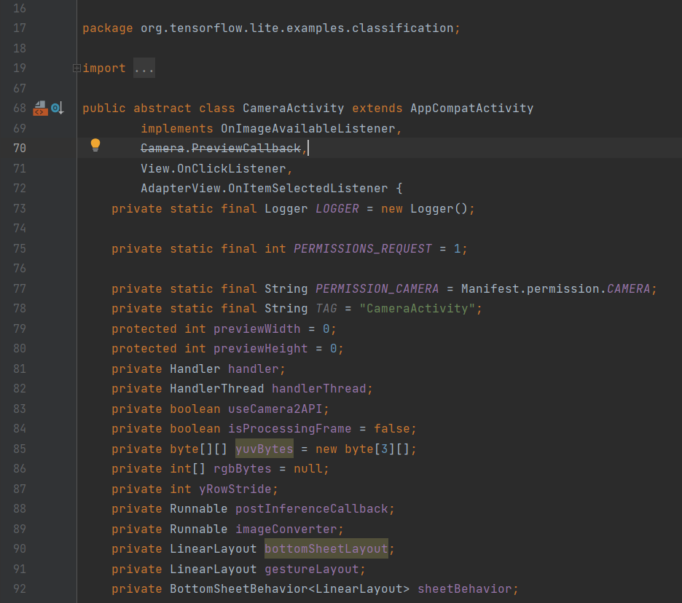

**Classifier Activity**

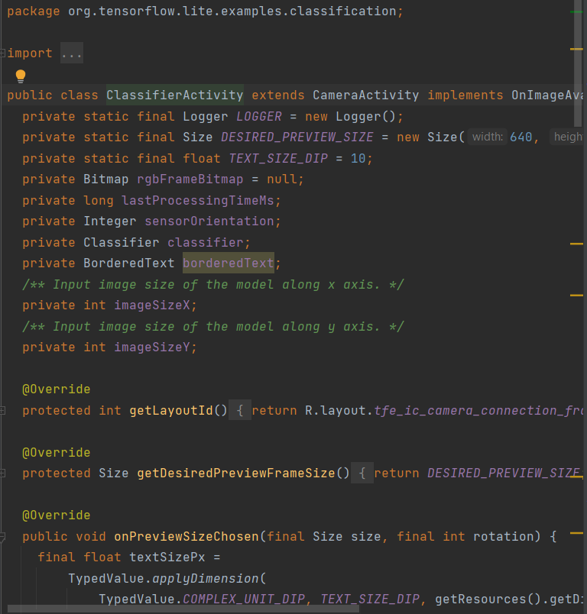

**ClassifierFloatEfficientNet**

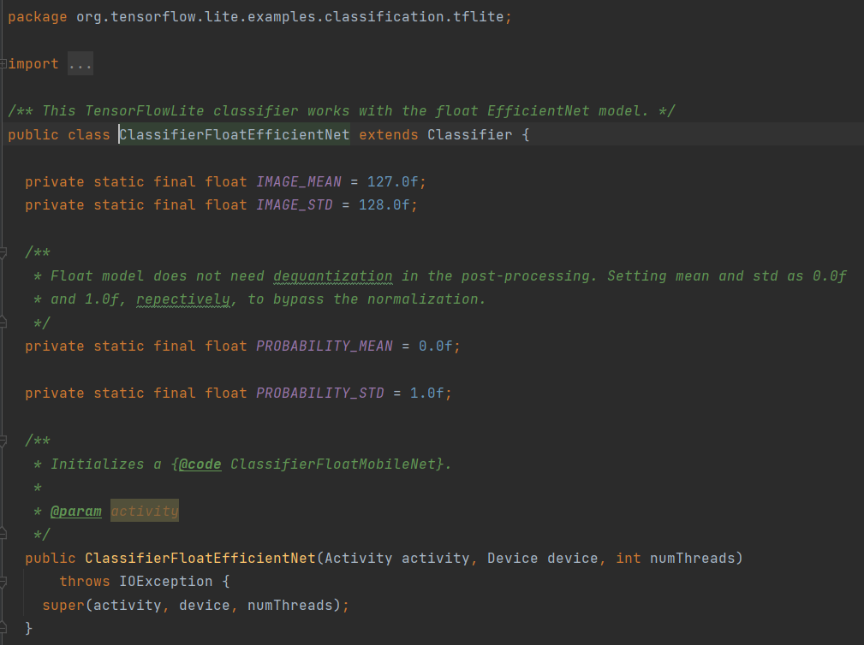

**CHAPTER-6:**

**PROJECT OUTCOME AND APPLICABILITY**

**6.1 Outline**

In this section we are going to see the outcomes of the project of the currency recognition.the outcomes various detected notes (10,100,500).

**6.2 Significant project outcomes**

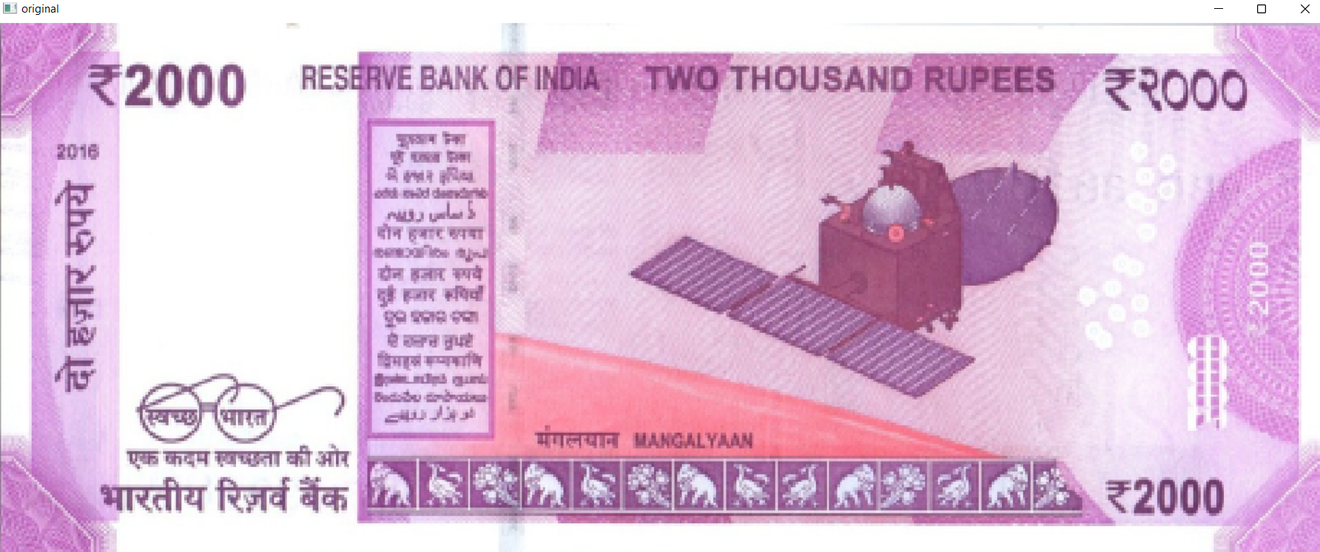

fig6.1 Original 2000 note

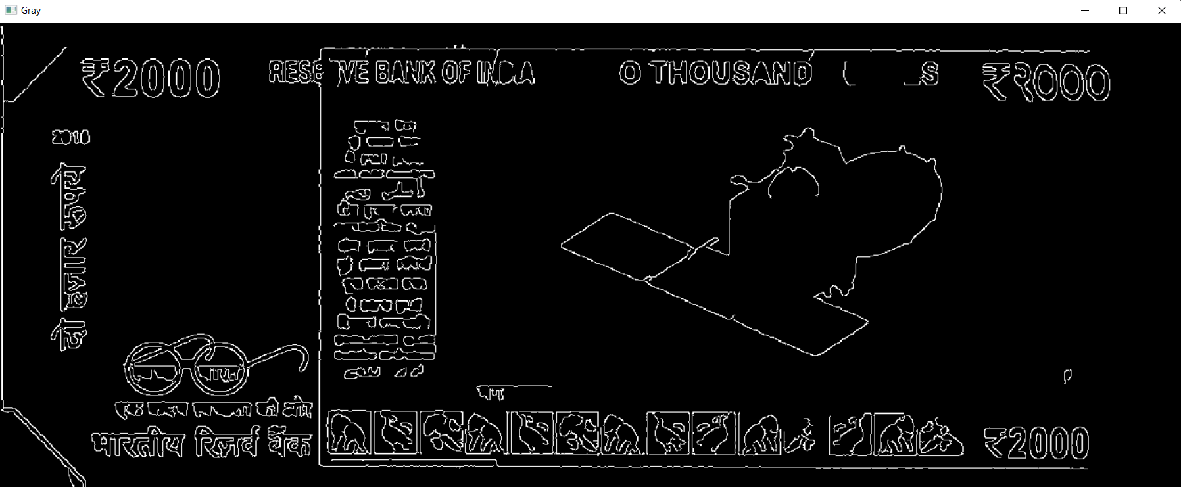

fig 6.2 processed dotted RS 2000 note

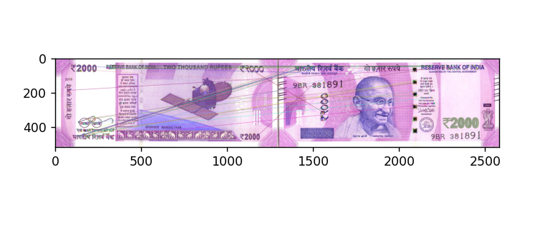

fig 6.3matching the training data with input(test data)

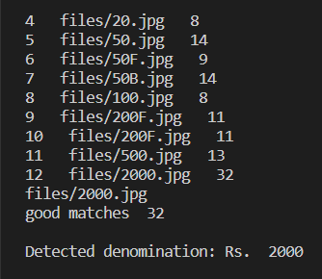

fig 6.4 detected denomination of RS. 2000

**Final Output:**

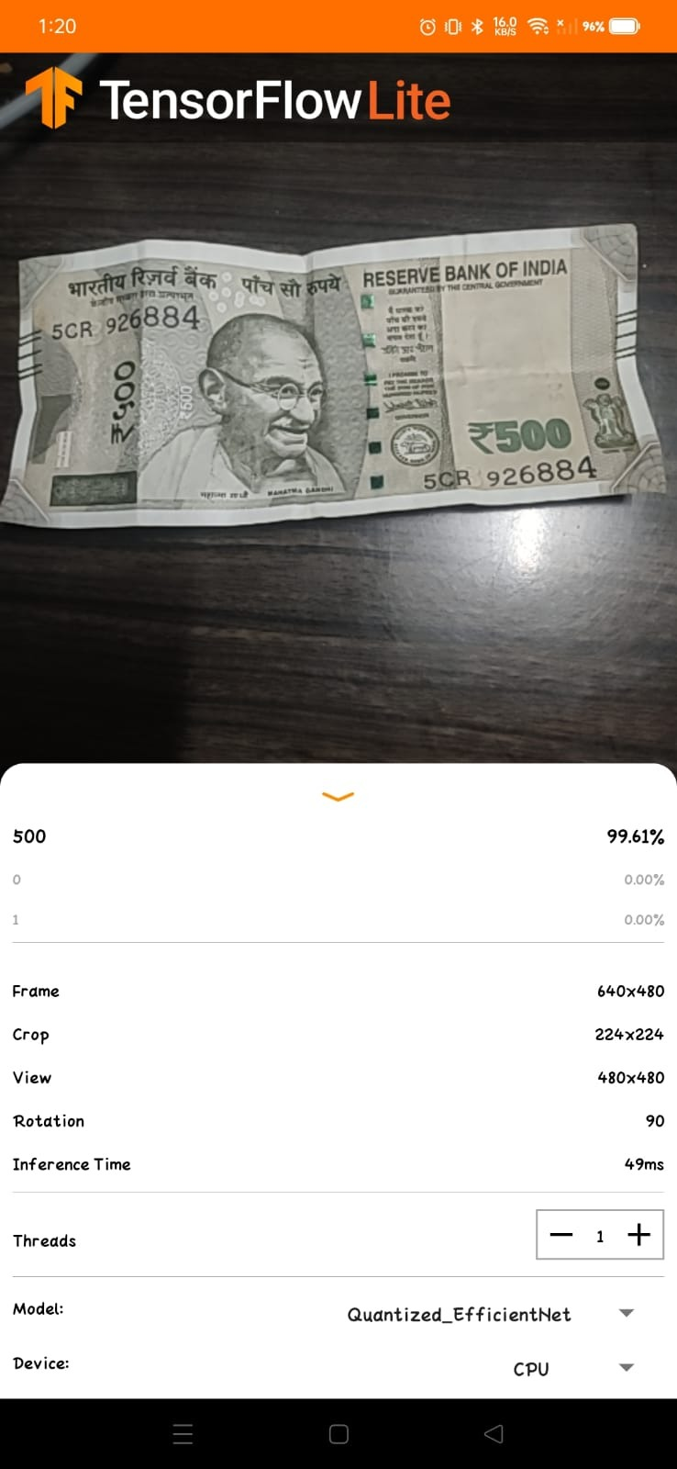

fig 6.5 detected RS 500 note

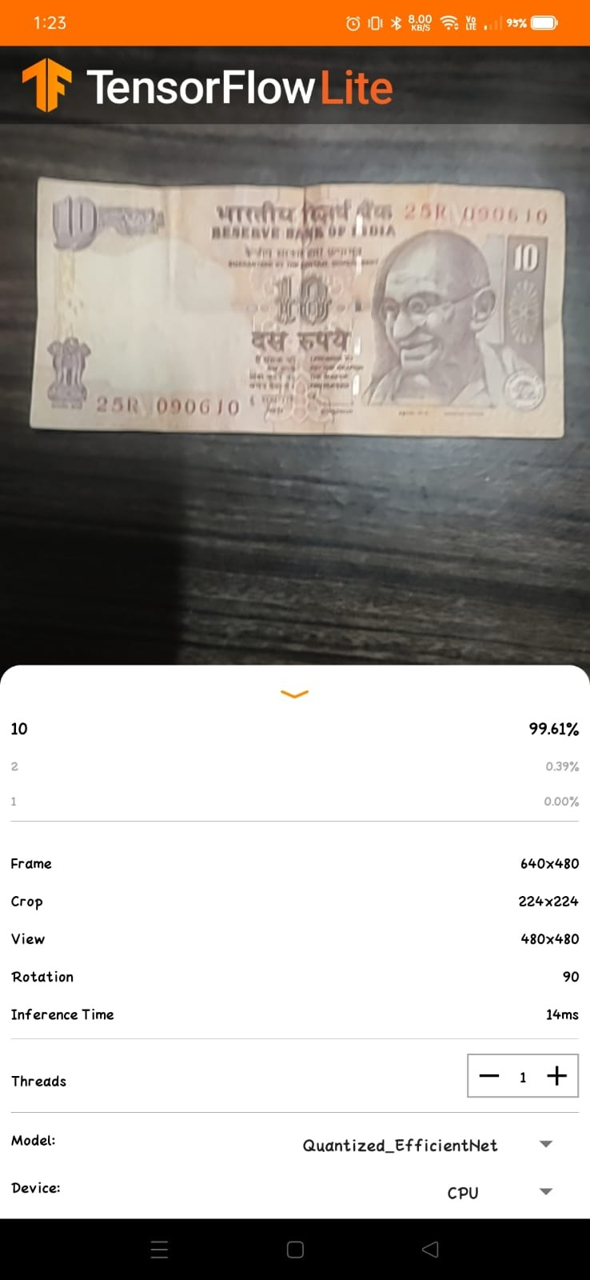 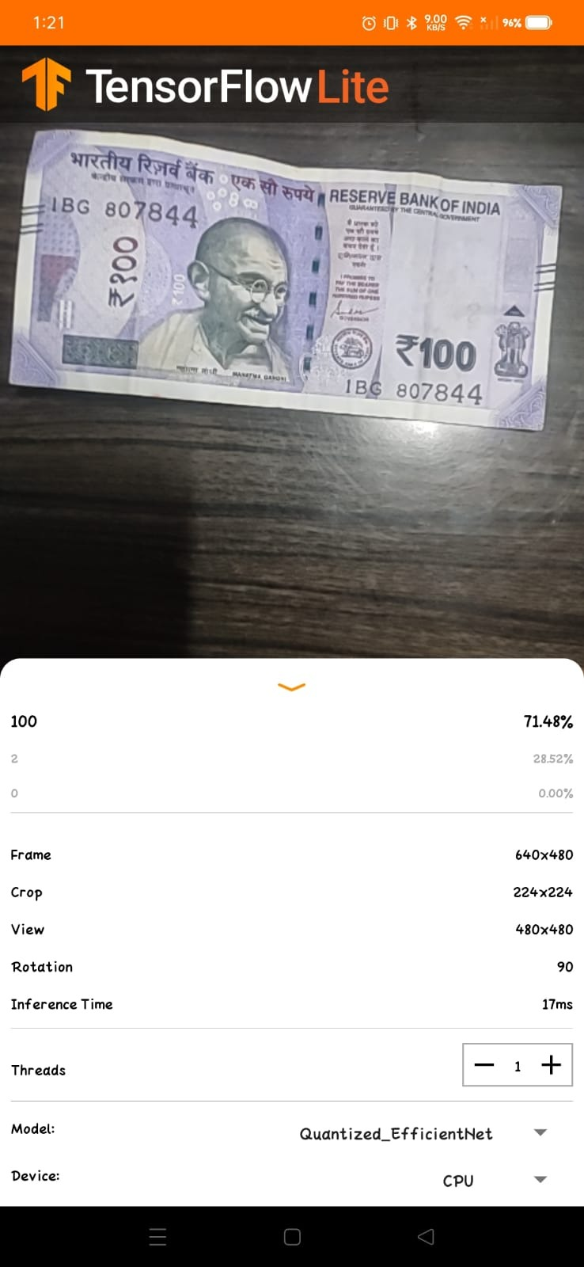

fig 6.6 detected 10 rupee note fig 6.7 detected 100 rupee note

**6.3 Project applicability on Real-world applications**

* Blind people faces many problems for the currency counting and also difficult to detect currency.​
* Our aim is to help blind people to recognize currency. Proposed system is based on image processing and makes the process automatic and robust.​
* Also counting number of notes and counting number of notes in bundles by seeing lines of each note and counting all the lines of the notes in the bundle of currency notes then we would be able to calculate the number of notes present in the bundle by using line detection algorithm. ​
* The way this python image programming works considering one line in one object.​
* Shape information are used in our algorithm. We are developing an image processing algorithm which will extract the currency features and compare it with features of original note image.​
* This system is cheaper and can provide accuracy on the basics of visual contents of note. So, as an output, blind people will get information provided the number of currency note can be calculated.​
* Also our project helps for Tourist People, foreigners, also work in banks for counting and detecting number of notes in a bundle

**CHAPTER-7**

**CONCLUSIONS AND RECOMMENDATION**

**7.1 Outline**

In this project we have proposed a method to identify the Indian currency notes by using opencv, python and image processing techniques. The currency notes have specific width and height, ashoka emblem and ae of different colors which are well extracted and processed here with the help of algorithms. Here the input is the form of image captured with the help of a webcam from the tenser flow app and undergoes various processing steps and finally the captures image is compared with the real image of the notes stored in the database and then after the comparison the output is obtained that what is the amount of the currency note and its value with high accuracy.

The project title is “Currency Recognition”. The main use of this project is to detect the value of the currency,not of notes in a bundle of notes.With a strong intention of helping visually handicapped people in recognising the value of notes,this project was chosen by us. We will create a model and give the model a dataset. This dataset has all currencies. It analyzes and extracts features on the currency.It identifies height, width and breadth, objects on note like Gandhi's pic, RBI Governor’s signature and mainly the unique picture at the back of note like sun temple, Qutub Minar etc. Then our sample note is compared to this model and then the currency is detected.Not only its detected but also the value is said out loud i.e we get vocal output also.

The model identifies the width,edges and estimates the number of notes in a given bundle.Edge detection n MATPLOT is used for this estimation.The proposed model is very cost effective and less time consuming. The model is very accurate at determining the value of Indian currency notes.This model has been made into an application which is very user friendly. We have to just scan the note using the camera. Then the scanner identifies the value of the currency and displays the value. We also get the value through the voice. In this way the blind people can easily identify the value of currency.

**7.2 Limitations of the project**

• The model is now only able to detect only Indian currency.

• The accuracy has to be improved in case of the number of notes detected in the bundle.

**7.3 Future Enhancements**

In future work, the blind people can access different countries' currencies and also they can give multiple inputs for image identification and also in the future we can calculate the net amount provided by the user. For the calculation of net amount we can use options by which the user can select according to required operation.The operations will be addition, deduction etc.. which acts like a calculator.

• Recognise all countries’ currency

• Accurately estimate number of notes in the bundle

• Detection of values of coins

**REFERENCE**

[1] Rubeena Mirza, Vinti Nanda, Paper Currency verification System based on characteristic Extraction using image processing, IJEAT, Vol.I, Issue 03, pp,68-71, February 2012.

​ [2]R. Bhavani, A. Karthikeyan, A Novel Method for Counterfeit Banknote Detection, IJCSE, Vol.2, Issue 4,pp 165-167, April 2014.

​ [3]Harish Agarwal, Padam Kumar, Indian Currency Note Denomination Recognition in color image and communication Tech. Vol.I​

[4]R. Bhavani, A. Karthikeyan, A novel Method for Counterfeit Banknote Detection, IJCSE, Vol.2, Issue 4,pp 165-167, April 2014.

[5] Aruna D H, Manpreet Bagga, Dr.Baljit Singh “A Survey on Indian Currency Note Denomination Recognition System”. International Journal of Advance Research in Science and Engineering, IJARSE, Vol. No.4, Special Issue (01), 2015.

[6] Vibhuti Vashishtha and Md. Sadim “A Paper Currency Recognition System Using Image Processing To Improve the Reliability with PCA

[7]Woods and Gonzalez (2008), Digital Image Processing (Third Edition), Pearson Education, New Delhi, 110092.

[8] Prof. Sowmyashree, Shreya Shetty, Trupti Ghotkar and Chirayu Yadav, “Currency Recognition and Fake Note Detection” International Journal of Research in Engineering & Advanced Technology, Volume 3, Issue 5, 2015.

[9] Hanish Aggarwal and Padam Kumar “Indian Currency Note Denomination Recognition in Color Images”. International Journal on Advanced Computer Engineering and Communication Technology, Vol-1 Issue: 1, 2014.

[10] D.Alekhya, G.DeviSurya Prabha, G.Venkata Durga Rao “Fake Currency Detection Using Image Processing and Other Standard Methods”. International Journal of Research in Computer and Communication Technology, Vol 3, Issue 1, 2014.